Guide 1. APT Project Definition
Capstone Course

}

- PART I
1. Personal Background

Student names | 1.Nestor Carvacho  2.Deyse Henriquez  3.Gary Villegas
National ID (RUT) | 1-17382965-5  2-19912787-k  3-21567657-9
Program | Information Technology Engineering
Campus | Puente Alto

2. APT Project Description
In the description you must briefly state the name of your APT project and the graduate-profile competencies you will put into practice. If your program defines fields of practice, also mention which field(s) of practice the project is linked to.

Project name | Khepri – Multi-tenant Warehouse Management System (WMS)
Field(s) of practice | Requirements engineering; software development; databases; software quality; IT project management; system security.
Competencies | Design and develop quality software solutions; design information solutions using databases; design and adapt requirements engineering processes; evaluate and manage IT projects; design solutions considering quality and security.

3. APT Project Rationale
Below are several fields you must complete with the requested information. This section aims for you to describe your project in detail and justify its relevance and pertinence.

Relevance of the APT project | The team chose this topic because, in practice, many warehouse-operating companies, especially SMEs that require logistics, still manage their inventory through spreadsheets, emails, and isolated records, which causes stock discrepancies, dispatch errors, and no traceability of who moved which product. This problem is highly relevant to the IT Engineering field, since solving it requires the integrated application of requirements engineering, database design, software development, and information security.  The problem identified directly affects warehouse supervisors and operators, company administrators, and managers who need real-time stock visibility to make decisions. Khepri's value contribution is to centralize multi-tenant inventory management, reduce manual errors, improve movement traceability, and give the administrator autonomy to manage the system without depending on third parties. These capabilities are also a great help for SMEs, which usually don't have the budget for costly commercial WMS solutions and, thanks to Khepri, could access an affordable tool to organize their warehouse operations.
APT Project description | The project aims to develop Khepri, a multi-tenant WMS web system that solves the problem described above by centralizing company, user, product, warehouse, zone, and inventory management on a single platform. It will be addressed through a modular hexagonal architecture (FastAPI, React/TypeScript, and MySQL), incorporating secure authentication (JWT), role-based access control (RBAC), movement traceability, PDF/Excel exportable reports, and a documented REST API, so that each company operates in isolation over its own data.
Relevance of the project to the graduate profile | The APT Project is directly related to the graduate profile because it requires going through the full software project cycle: requirements gathering, architecture and database design, development, quality control, and project management. These competencies are necessary because, without requirements engineering, the multi-tenant scope could not be properly defined; without database design, per-company data isolation could not be modeled; without quality software development, a stable solution would not be achieved; and without project management and security, deadlines could not be met nor each client's information properly protected.
Relation to professional interests | This project connects with what each of us wants to do going forward, even if for different reasons. Deyse has always been more interested in the project management and information analysis side than in programming itself, so on Khepri she can gather requirements with the client and keep track of deadlines. That's exactly the area she feels she needs to strengthen, so this project lets her practice it on a real case instead of just in theory. Néstor most enjoys getting into how a solution is built on the inside: the architecture, how the database is organized, how the modules are separated so it doesn't turn into a mess. That's why he takes on the architect role, designing the multi-tenant model in MySQL and setting things up so it can later be deployed on Railway without issues. It's an opportunity to make real technical decisions, which is the direction he wants to grow in professionally, along with information analysis. And Gary is most motivated by coding end to end: taking a requirement and leaving it working, seeing how everything connects. On this project he took on the frontend, building the interface in React and connecting it to the API, but he is also interested in continuing to explore the rest of the system. He wants to strengthen security and good practices before adding things like AI to his work, and this project is a good excuse to get that in order. In short, each of us got into the project for a different reason, but all three of us feel it lets us practice what we're missing: Deyse in management, Néstor in architecture, and Gary in building a complete solution with good practices. And despite being in these positions, we don't rule out having professional interests that go beyond the technical side, we are also interested in leading projects of any kind.
Feasibility of developing the APT project | The project is feasible to develop within the 18 weeks of the academic term (08/20/2026 to 12/10/2026), considering the hours allocated to the Capstone course and their distribution across the three evaluated phases. The team has the necessary materials and resources, such as its own computers and development tools like FastAPI, React, TypeScript, MySQL 8, Git/GitHub, Docker, and Railway, all free to access or already available to the team.  Among the factors that facilitate its development are that we are three members with complementary roles and that we have prior knowledge of some of the tools and methodologies used. In addition, this project has already been studied beforehand, which makes gathering requirements and planning the phases easier. On the other hand, the workload from the professional internship and the technical complexity of the multi-tenant system could hinder progress. To reduce these risks, a Gantt chart, balanced task distribution, and periodic follow-up meetings will be used, allowing progress to be monitored and adjustments made when necessary.

- PART II
4. Objectives
In this section you must define the general and specific objectives of the APT Project. It is important to clarify that objectives should be stated clearly, concisely, and without further explanation, that is, they should be self-explanatory. It is suggested to write them using an infinitive verb, as this forces you to specify concrete actions.

General objective | Develop Khepri, a multi-tenant warehouse management system (WMS) that centralizes user, product, warehouse and inventory movement management, incorporating security, traceability and reporting for logistics operators and companies with one or more warehouses.
Specific objectives | First, gather and document the system's functional and non-functional requirements, use cases, and mockups.  Second, design the hexagonal architecture and the multi-tenant relational data model in MySQL 8.  Third, develop and integrate the system's backend (FastAPI) and frontend (React 19 and TypeScript).  Fourth, implement secure authentication, session management (JWT), and role and permission management.  Fifth, implement the inventory module (receiving, transfer, and dispatch), PDF/Excel exportable reports, and a documented REST API.  Finally, run tests on the critical modules and document the architecture, the API, and the user manual.

5. Methodology
In the following section you must describe the methodology, specific to your discipline, that you will use to solve the APT project described above, including the stages and working methods.

Description of the Methodology
The project will be developed using a traditional methodology, organized into sequential macro-phases: planning, design, development, testing, and closure, each evaluated across the course's three weighted phases. However, within each phase, tasks are executed in parallel according to each member's role, for example, during development, the backend and frontend are built simultaneously for the same modules, and quality control (good practices, unit testing) is applied continuously throughout the development phase, not only at the end. Roles are distributed as follows: Deyse Henríquez as project lead, in charge of planning, requirements, and closure; Néstor Carvacho as software architect, also responsible for quality and testing; and Gary Villegas as frontend developer, also mockup/UI designer. Progress is tracked through the Gantt chart and periodic follow-up meetings.

6. Evidence
Below, describe which evidence will be evaluated in the progress report and in the final report of your APT project. This evidence must be agreed upon with your instructor. Evidence is understood as the products developed during the project whose purpose is to make visible or document how the work has been implemented.

Evidence type (progress or final) | Evidence name | Description | Justification
Progress | Project Charter | Document that formalizes the Khepri project, including general information, sponsors, milestone schedule, estimated budget, objectives, scope, high-level requirements, and initial risks. | Demonstrates the formal definition and initial approval of the project by the team and the supervising professor.
Progress | Gantt Chart | Time planning of the project's activities distributed across the semester's 18 weeks, organized into planning, design, development, testing, and implementation phases, with responsible members assigned per task. | Demonstrates the planning and schedule tracking of the project throughout the three evaluated phases.
Progress | SRS Report | Software Requirements Specification detailing the functional requirements of the Khepri system. | Demonstrates the formal and structured gathering of the system's requirements.
Progress | WBS Matrix | Work Breakdown Structure of the project, including effort calculation per task and role. | Demonstrates detailed work planning and resource estimation for the project.
Progress | Requirements Sheet | Detailed list of the functional and non-functional requirements identified for the Khepri system. | Demonstrates the traceability and level of detail of the requirements that will guide development.

7. Work Plan
In the following table, define your APT Project's planning as requested.

APT Project Work Plan
Competency or competency units | Activity/Task name | Activity/Task description | Resources | Activity duration | Responsible | Notes
IT project management | Team organization and Project Charter | Team organization and drafting and approval of the Khepri project charter. | Meetings, Word/Excel | 13/08/2026 – 21/08/2026 | Deyse Henríquez | Base for the rest of the project planning.
Requirements engineering | Requirements gathering and use cases | Drafting of the requirements sheet (R.1–R.45), extended use case document, system mockups, and SRS Report. | Documents, meetings, Word/Excel/GitHub | 20/08/2026 – 08/09/2026 | Deyse Henríquez / Néstor Carvacho / Gary Villegas | Risk: scope changes during the definition stage.
IT project management | Project planning and control | Drafting of the WBS Matrix, the Gantt Chart, the RACI Matrix, the risk matrix, and the change control matrix. | Excel, repository, meetings | 20/08/2026 – 01/10/2026 | Deyse Henríquez | Risk: work overload. Mitigation: weekly progress follow-up.
Databases | Architecture and database design | Drafting of the Software Architecture Document (SAD), MySQL 8 data dictionary, development environment, Docker Compose, and Railway deployment. | MySQL 8, Docker, Railway, DBeaver | 11/09/2026 – 01/10/2026 | Néstor Carvacho | Risk: complexity of the multi-tenant data model.
Software development | Backend and frontend development | Implementation of the IAM module (authentication and roles), Tenant module (multi-tenant), Catalog, and operational Inventory (receiving, transfer, dispatch), along with the documented REST API. | FastAPI, React, TypeScript, GitHub | 01/10/2026 – 12/11/2026 | Néstor Carvacho / Gary Villegas | Risk: integration between modules and possible technical delays.
Software quality | Testing and quality control | Setup of the testing environment, functional testing per requirement, user testing (operator/warehouse supervisor), and defect logging. | Pytest, navegador, GitHub | 13/11/2026 – 03/12/2026 | Néstor Carvacho | Risk: errors or vulnerabilities found in final stages. Mitigation: a second round of quality control and testing with Gary Villegas's help.
IT project management | Final closure and implementation | Final deployment on Railway, drafting of the user manual, training/demonstration, and project closure charter. | Railway, Word, meetings | 01/12/2026 – 10/12/2026 | Deyse Henríquez / Gary Villegas | Corresponds to the Phase 3 final delivery. Possible risk: not finishing the project within the agreed deadline.

8. Gantt Chart
Find a Gantt chart format that suits you and organize the activities planned in the previous section, considering the period assigned for the development of your APT Project. You must keep the academic-period timing in line with the three phases covered by the Capstone Portfolio course.
The Gantt Chart is attached, as it more thoroughly covers the planning of the APT's development.
Carta Gantt.xlsx

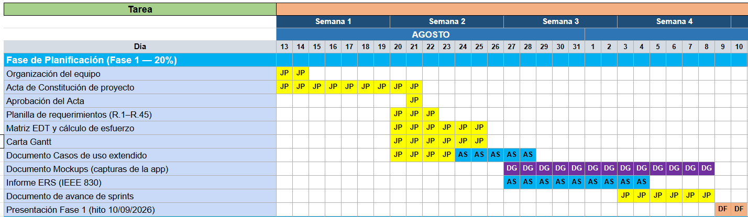
Phase 1

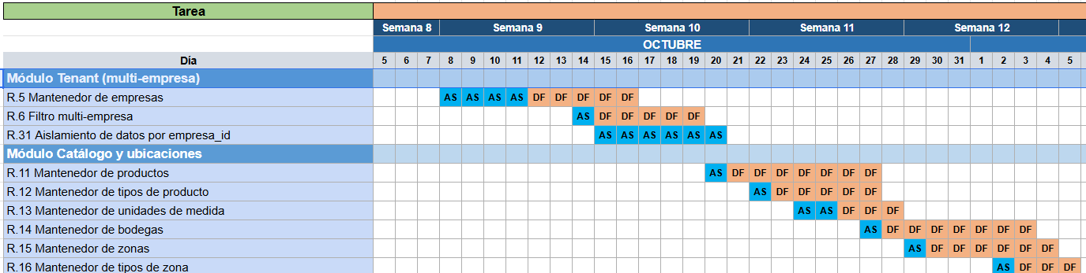
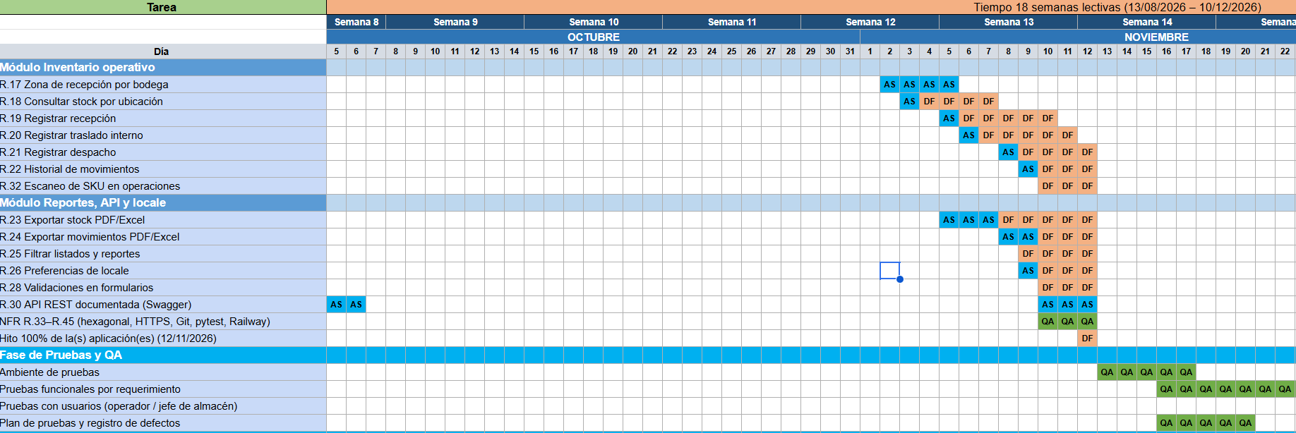
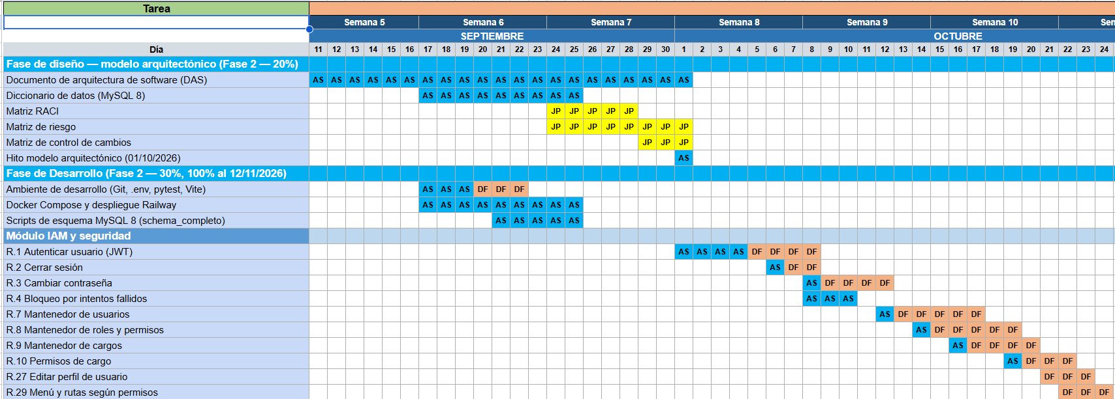
Phase 2

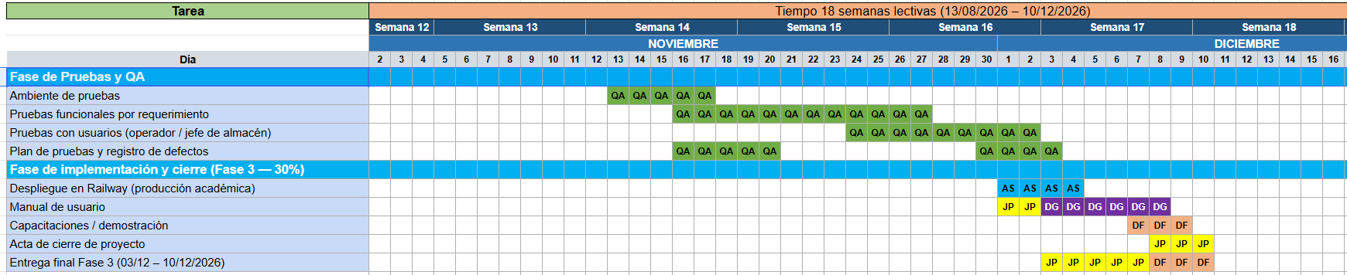
Phase 3

